Project Report

Project Title: Agricultural Biotechnology: Assessing Perceptions of Farmers, Consumers and Extension Agents and Providing Training Workshops for Stakeholders in Ghana

Introduction
Researchers from Tennessee State University, Tuskegee University, and Alcorn State University with their partners at the University of Ghana-Legon and the Crop Research Institute, Kumasi, Ghana conducted training workshops on Biotechnology from 28th February to 7th March, 2010. This was the second phase of a USDA-Foreign Agricultural Service-funded project to access the perception and attitude of Ghanaian agricultural stakeholders on biotechnology and biotechnology products.

Overall Goal:
The goal of the overall project was to establish an understanding of the potential impact of agricultural biotechnology and its applications to food production, consumption, trade and economic/agricultural development in Ghana.

Objectives:
The objective for this particular phase of the project was to organize workshops to:
  - Increase awareness of biotechnology among consumers and producers.
  - Increase awareness of biotechnology among educators, pre-college and college students.
  - Educate the stakeholders including policy makers and journalists on the essence of biotechnology and its potential for increasing agricultural output and improving food security problems in Ghana.
Procedure:

The following were involved in conducting the biotechnology training: Kwame Offei, Augustine Tonyigah, and Rodney Owusu-Darko (University of Ghana, Legon); Korsi Dumenyo and Samuel Nahashon (Tennessee State University), and Conrad Bonsi (Tuskegee University). Program participants were recruited with the assistance of Ghanaian counterparts. There were three groups of participants: agricultural extension agents, high school science teachers and the last group comprised of farmers. Pre- and post-workshop surveys were conducted for all stakeholder groups. The instruction and discussion sessions included various subjects such as the understanding of benefits and perceptions on the safety of genetically modified foods by farmers, consumers, producer and both current and future agricultural workforce.
Three consecutive workshops were conducted to the three stakeholder groups whose understanding and approval will be important in the adoption and wide-spread use of biotechnology in Ghana. The workshops involved classroom type lectures including questions and answer session, as well as hands-on sessions in the research laboratories of Biotechnology Centre of University of Ghana. The hands on exercises included the isolation of DNA from banana and the visualization of the DNA on agarose gels.
Results:
The groups comprising agricultural extension Agents and Biology teachers (but not the farmers) had the opportunity to extract DNA from banana fruits using common household products including table salt, dishwashing detergent and rubbing alcohol. They also run the DNA on the gel as a way of demystifying the technology, getting them familiar with DNA and to drive the message home that all organisms contain DNA. The workshops were a big success with close to 100 stakeholders attending. The participants particularly liked the question and answer sessions which gave them the opportunity to have their questions, misgivings, uncertainties, reservations and doubts cleared.
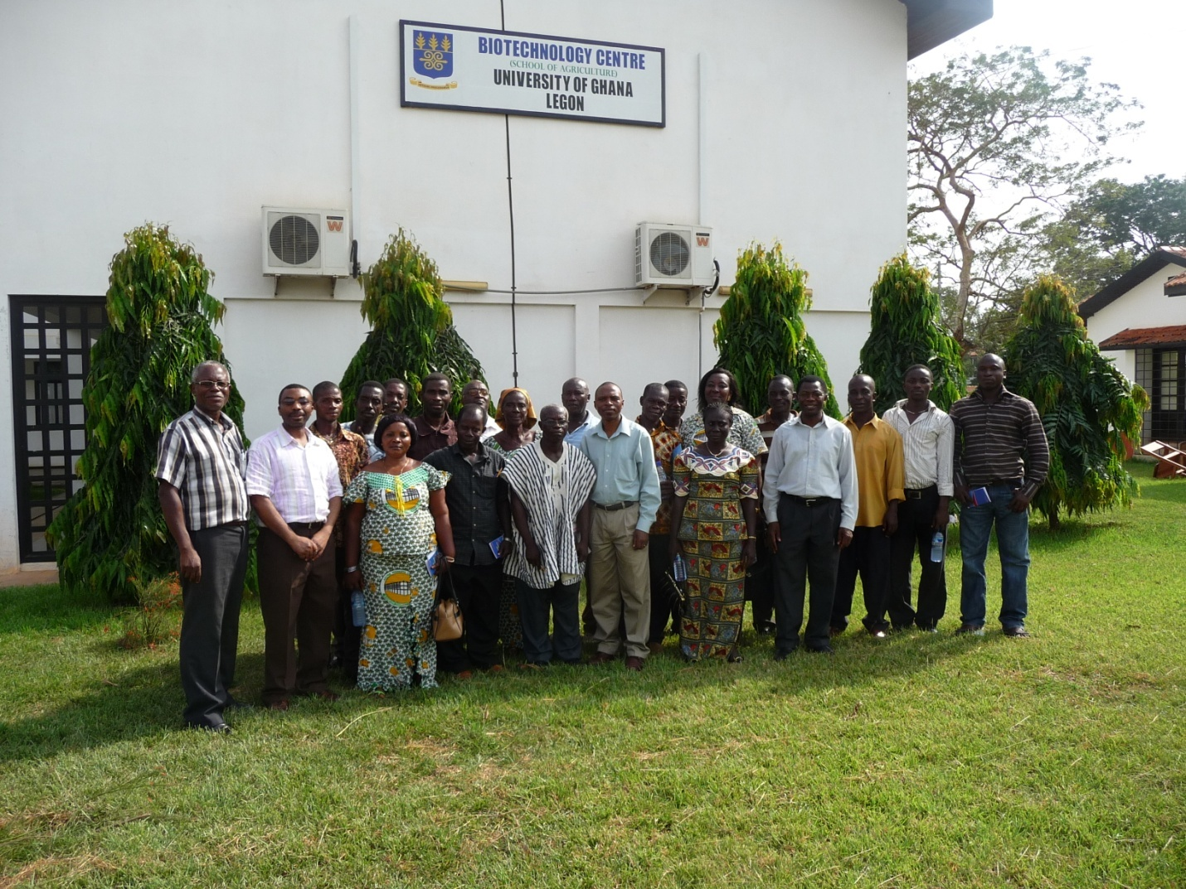
Workshop participants (Agricultural Extension Agents) together with the trainers.

